# Yumbo Website Proposal – Skin Design (PSD)

The purpose of this document is for a designer to design a skin for our website to be provided in a PSD format. This PSD will than be converted to HTML/CSS for the Yumbo.com.au Website.

We require the following items:

* Landing Page Design

Landing Page Template

We would like to see something similar to this for our site.

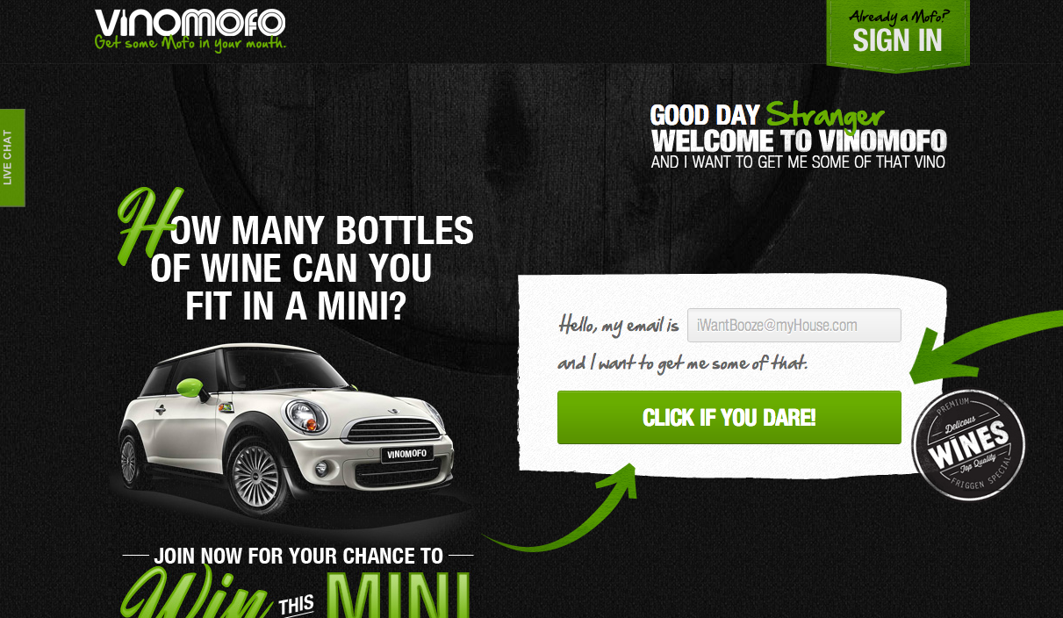

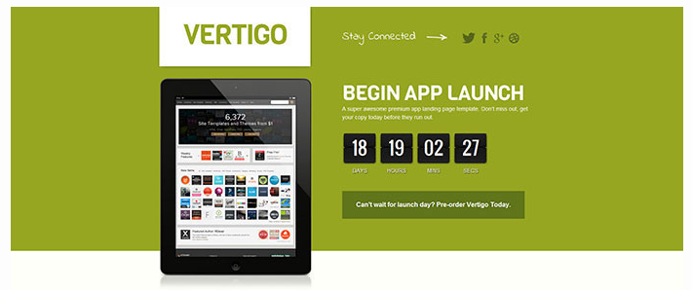

**What we want to change:**

* We have our own logo. Should replace their logo
* **Replace**: The car with a picture of Gold Bullion worth 25k.
* **Replace:”**How many bottles of wine can fit in a mini? **With**: Yumbo is a unique shopping experience that will revolutionize how people shop online in Australia.
* **Replace**: Good Day Stranger Welcome to VinoMofo and I want to get me some of that vino  
  **With:** Good Day Stranger Welcome to Yumbo
* **Replace:** Win This Mini  
  **With:** Win 25k in Gold Bullion
* Remove the Premium Wines stamp.
* Colours should use our colours found at [www.yumbo.com.au](http://www.yumbo.com.au) Instead of Green we would like purple.
* We should have room for a video on the site, maybe above the car. We also have a mascot that can be used on the site.
* Enter e-mail now should just collect their details and store them.
* We would like to have a countdown clock on the page.
* After the user enters their details they should be taken to a page that thanks them and lets them know that we will be in touch. We could use one of our mascots for here as well.

## Overall Website Skin

We are mostly happy with our current website skin, so feel free to use any of the pictures and content from this. There are a number of items that we will want to improve.

Currently this area at the top (Credits Bar, Logo, Search, Nav bar) is taking up to much room. We would like to shrink this so that it doesn’t take up so much room above the fold.

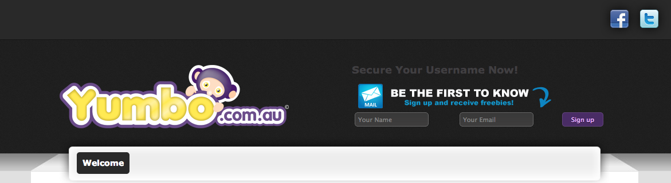

The section to the site of the logo will be different depending on if the user is logged in or not. If the user is not logged in that they will be encouraged to sign up. So we would like a sign up design done for this. If the user is logged in that that section should be changed to a design that encourages the user to buy credits.

### Add a Ended Auctions section

We require a new page that lists all of our ended auctions.

A page with the below boxes showing the same information provided in the screen shot below of all ended auctions.

This information will need to dynamically be pulled from the database.

These ended auctions will be listed in a grid like system across and down the page.  
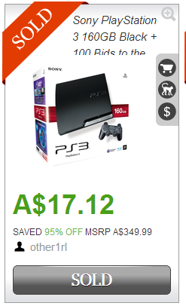

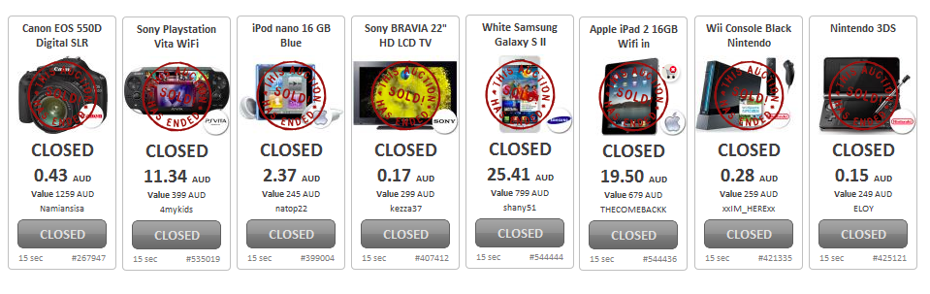

**\*\*\*Provide more information about the logic of this \*\*\*\***

### Update Product Details Page

<http://yumbo.com.au/browse/productdetails.aspx?ProductID=22>

1. Insert Tabbed Integration. - Overview, Tech Spec, Warranty, Shipping

Look similar to the below. Should be bigger and a different colour (Grey).  
  


1. Need to insert the Option to Share on twitter Facebook and Email to a friend. This could be placed under the Buy Now Button. Should be in line with the tabs. Better icons will be required.

Macintosh HD:Users:johnnymac:Desktop:Screen Shot 2013-11-30 at 10.01.52 AM.png

A very poor mock up design can be seen below.

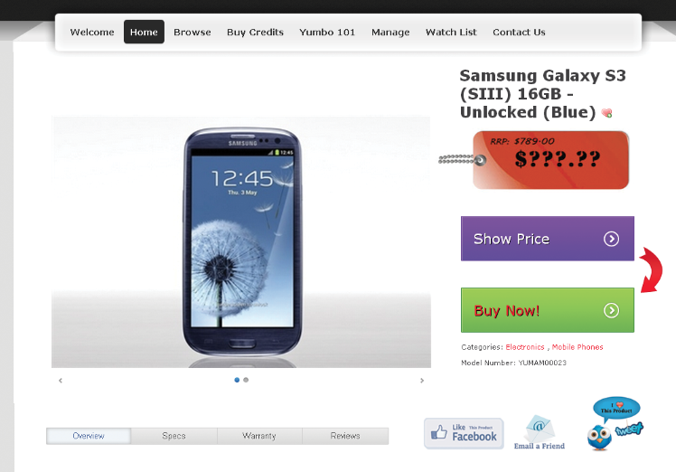

1. How it works section. This is located down the right hand side. An example can be seen at the below link. This will be required on every product page. <http://yumbo.com.au/browse/productdetails.aspx?ProductID=22>
2. Currently our site looks like the below screen shot. We would like to make the RRP smaller and really make the Your Price section the larger part.  
   Add an OR in between the Show Price and Buy Now buttons to make it look like it’s a choice.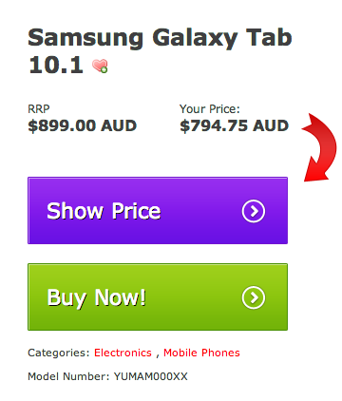

### Confirmation Show Price Popup.

**Action**: The customer clicks show price. We would like to update this to use the following information. This should be shown when the user clicks the show price button on the Product Details Page.

We would like to improve the design and have the same look as the product details page.

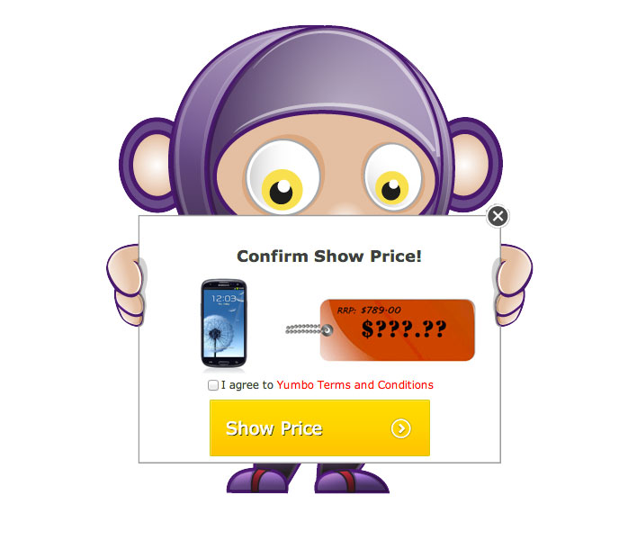

### Your Price Page

We would like to improve the design of this page. An improved design similar to the below should be shown on this page. This should be shown when the customer clicks on the show price button on the confirm show price pop up.

<http://yumbo.com.au/Browse/ProductDetails/Confirm/ItemPrice.aspx>

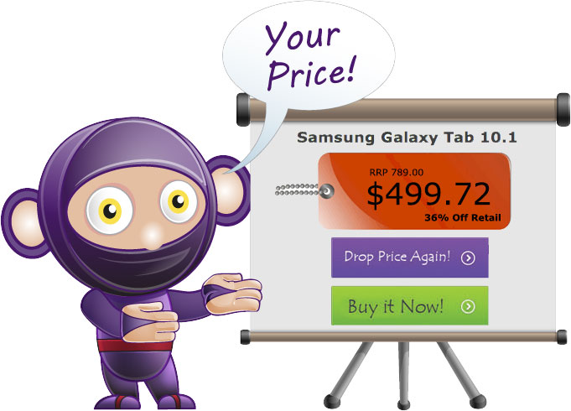

### Payment Process Step 1

<http://yumbo.com.au/browse/productdetails/confirm/itemprice/pay.aspx?ProductID=22>

We would like to improve the design of this page. The green should be changed to Purple. The same design would need to be applied to the Support a Charity Module. So that the design fits with the entire page. The users details if available in the database should be pre populated. If the user does not have his details than the item will be blank.

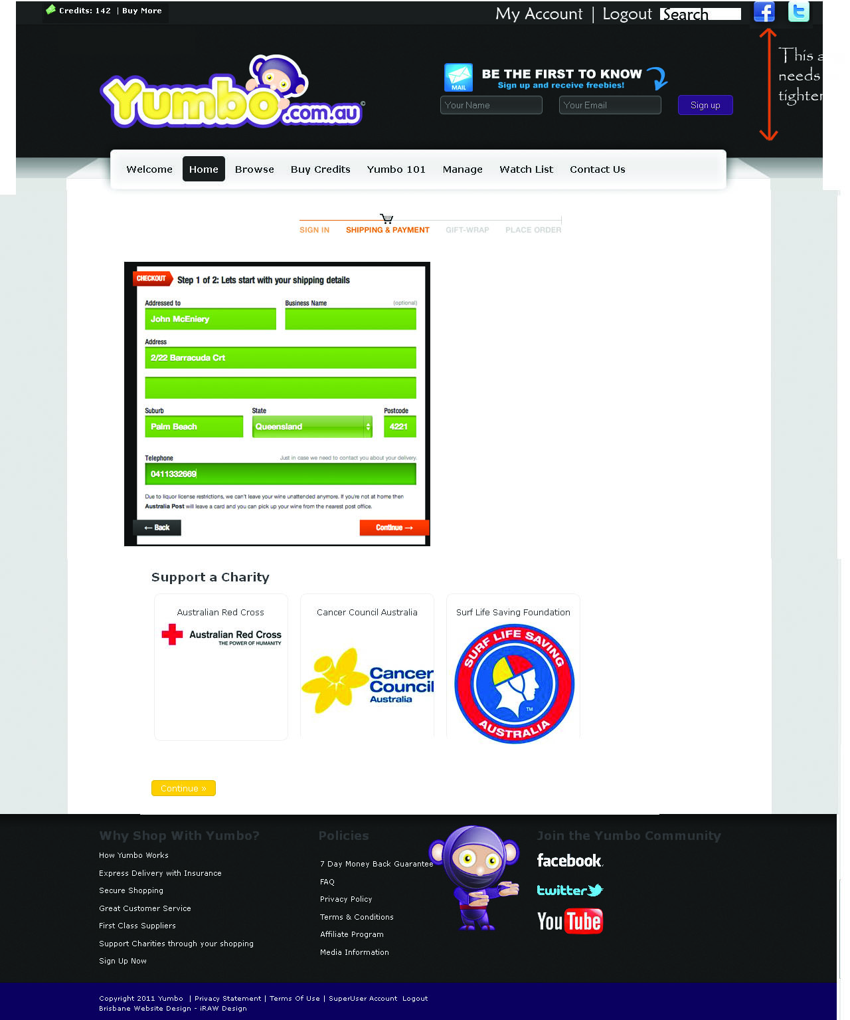

## Payment Process Step 2

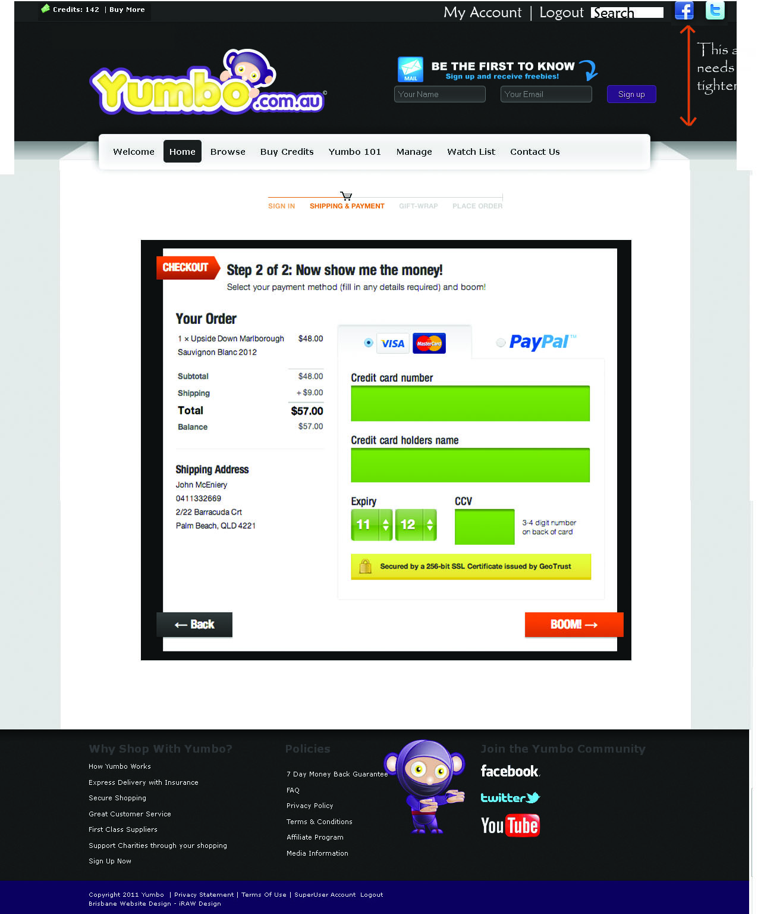

### Payment Process Step 3 – Success

### Macintosh HD:Users:johnmceniery:Desktop:Payment-Process-Step-3.jpg

## Payment Process Step 3 – Unsuccessful

If the order process is unsuccessful then a design similar to the below should be shown. We would like to improve the below design.

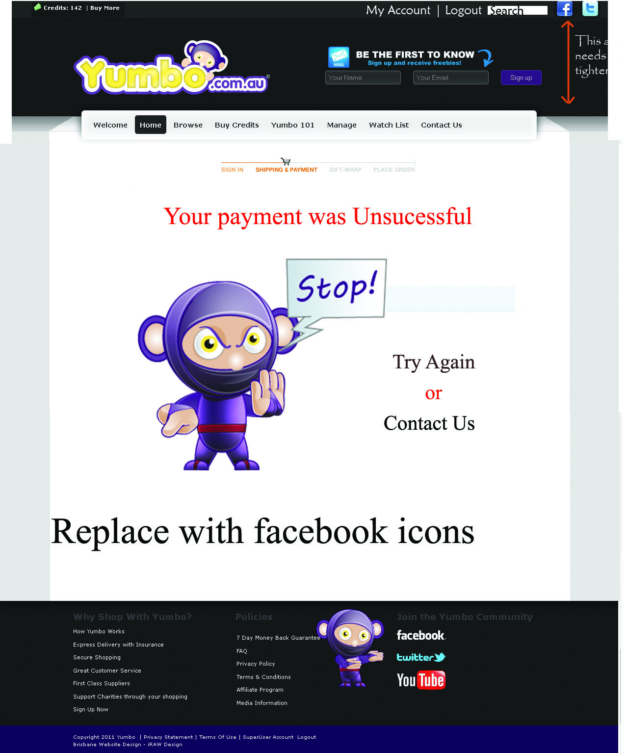

View my order online – Sends to control panel

### Buy Credit Page

Needs a revamp to look similar to:  
  
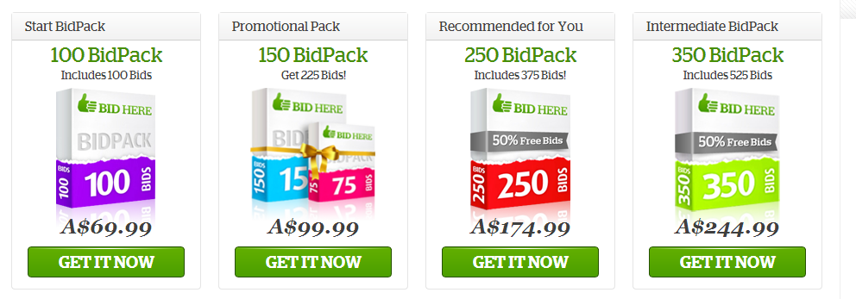

Corresponding payment page will need to be updated as well to suit the above layout

### Control Panel

This page is the customer account section. It should be split into sections to looks similar to the picture below. We should be able to update and change the order to anything that we like. As well as add/remove items

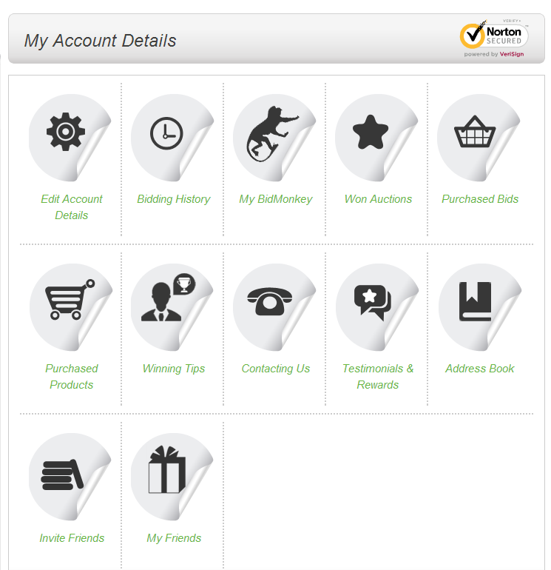

The sections we will have are:

**Edit Account Details**

**Bidding History**

**Won Auctions**

**Purchased Bids**

**Winning Tips**

**Contact Us  
Testimonials & Rewards**

**Earn Money**

**Watch List**

**Shipping Information**

#### Edit Account Details

Should look similar to the below using our colours

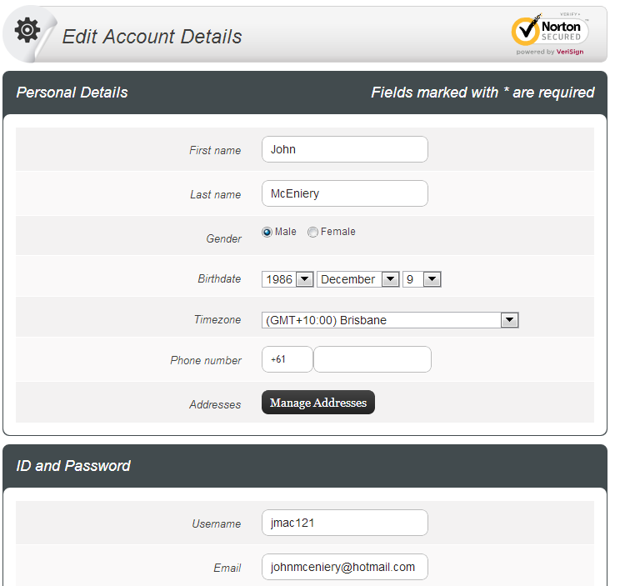

#### Bidding History

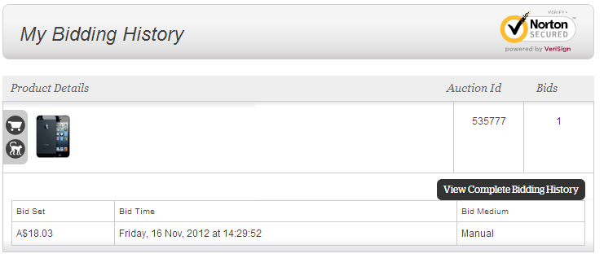

*Should have the name of the product!

Product Title, Picture, Link to the product details, Auction ID, Number of Bids and then a list of bids… Show Price Amount, Bid Time.

#### Won Auctions

Should look similar to the below using our colours.

Should have Product Name, Sale Date, Price Paid, Shipping Cost, Posted Date, Tracking ID, Product ID, Auction ID  
  
These items should be laid out nicely with icons where necessary.



#### Purchased Bids

Should look similar to the below using our colours.

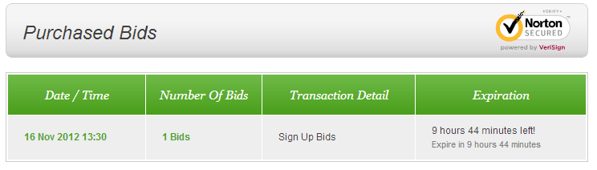

#### Watch List

Similar layout to this:  
  


*Should have the name of the product name and Auction Status “Closed or Live or Won”

Your Price, and how much they would currently be saving, Should have the same feel as if they were on the product details page.

Should be able to go show price and buy it now from here as well.

### Browse Page

<http://yumbo.com.au/en-us/browse.aspx>

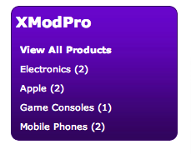

We would like to improve the current design. We would like a new side menu. Something better than the above. We are open to suggestions.

### Suggest Auction Item

<http://yumbo.com.au/en-us/browse/suggestitem.aspx>

We would like to skin this section like the below with our colours.



#### Add Credits to User

<http://yumbo.com.au/Manage/AddCreditstoUser.aspx>

We require a better way to look for users then our current way. Something similar to the standard DNN user accounts layout would be better.  
  
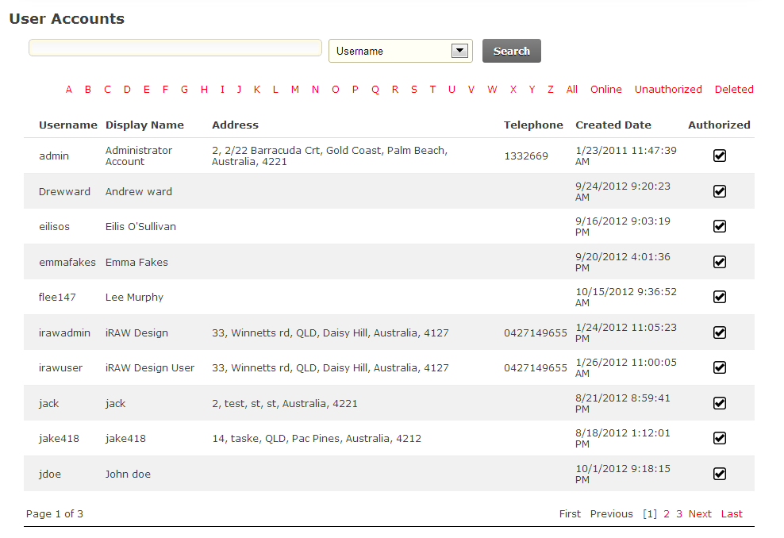

If each user could have a text box beside it that we could then place the credits # in. And a single Add box at the bottom to add the credits to the user.